**Lecture 01 (What is jQuery)**

* It’s a js library i.e. it has prewritten code that we can use.
* It reduces js code that looks like this

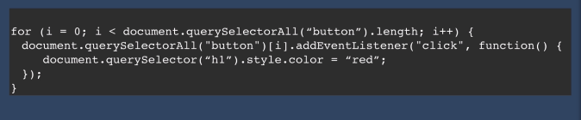

To something like this

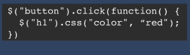

* Jquery shortens code like this



To this



**Lecture 02 (How to incorporate jQuery into websites)**

* You can download the files and include them in your project
* Or you can use a cdn link to include it in your website.
* The most popular option across the web is to use Google CDN since there is a pretty good chance that the user will have those files already cached on his computer.
* You can add if via google’s cdn from this website

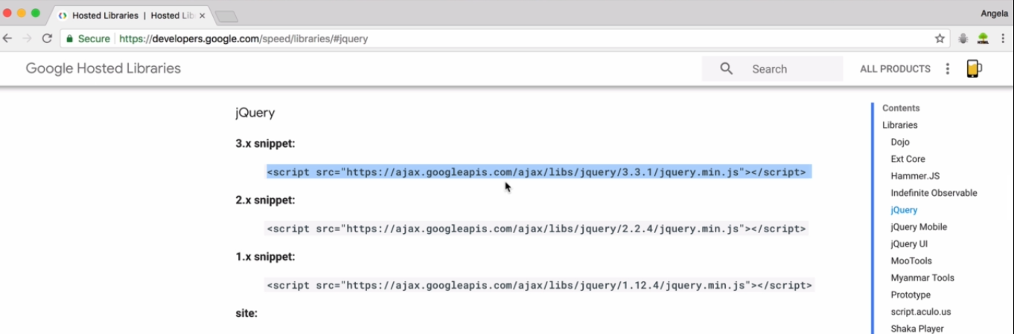

* To make sure that your jQuery library has been loaded and only then your function executes we uses a higher order function $(document).ready(//call-back function here) like this

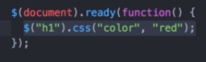

* Or you can simply put the src tags for jquery as well as your own javascript at the end of the body tag so that you don’t have to use the ready() function.

**Lecture 03 (How Minification works to Reduce File Size)**

**Lecture 04 (Selecting Elements with jQuery)**

* Instead of writing document.querySelector(“h1”) In js, we can write $(“h1”) in jquery to select the same h1 element.
* If we want to select all elements of a same tag in js we would have to use



But in jquery we write



Basically there is no difference in selecting a single element or all elements of the same tag in jQuery.

* If you have 5 buttons on your website like this

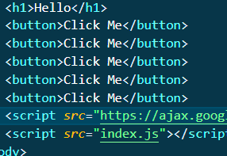

* And if you want to change inner text of these buttons using jQuery you can do so by

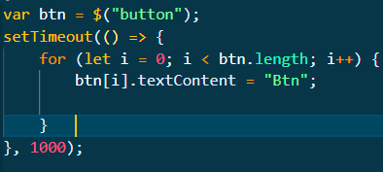

**Lecture 05 (Manipulating Styles with jQuery)**

* You can change css properties of elements by this method.



* Or if you just want to save the value of the property then only pass the name of the property in the first argument of the function.



Will return the value of h1’s color.

* You can add a class to the element using the following method with jQuery



* You can also remove classes in a similar way, this method is preferred since it separates our concerns and doesn’t let js deal with the design part of our website.
* To add more than 1 classes add them in a single set of quotation marks with a single space like this



* You can also check whether a certain element has a css-class or not by using the has-class method.



It will return a Boolean true or false value.

**Lecture 06 (Manipulating Text with jQuery)**

* You can change the text of an element using jquery by



* You can also use the inner html functionality used in vanilla js by instead using the html function like this



**Lecture 07 (Manipulating Attributes with jQuery)**

* You can modify attributes of an HTML element using the following jQuery commands



* To change the href attribute we can write



**Lecture 08 (Adding Event Listeners with jQuery)**

* To add an event listener using jQuery you can use the click function and pass the callback function in the click function like this.

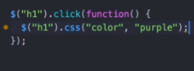

* Below is the js and jQuery code for changing the color of h1 when a button is clicked.

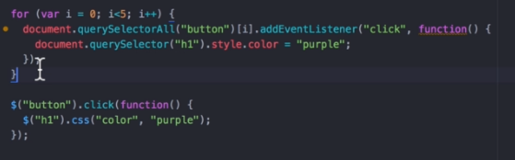

* In jQuery you don’t have to manually select all buttons since $(“button”) automatically selects all buttons.
* You can also add any javascript event to an object using the “on” function in jQuery,
* It takes 2 parameters, the first parameter is the name of the event (click, keypress, mouseover etc) and the second parameter is the callback function.
* Here we add an event on the h1 tag that changes the color of the heading when a mouseover event occurs.

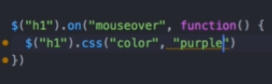 ­­

**Lecture 09 (Adding and Removing Elements with jQuery)**

* You can add new Html elements to your webpage on the fly using the before, after, prepend and append methods.
* All these methods take the HTML of the new element as an argument in the parenthesis.
* Following picture shows how each of the methods behave differently from each other.

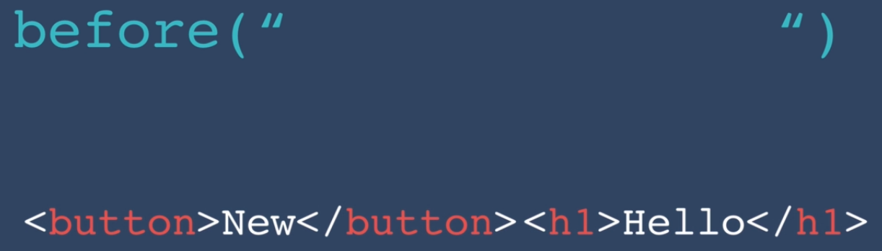

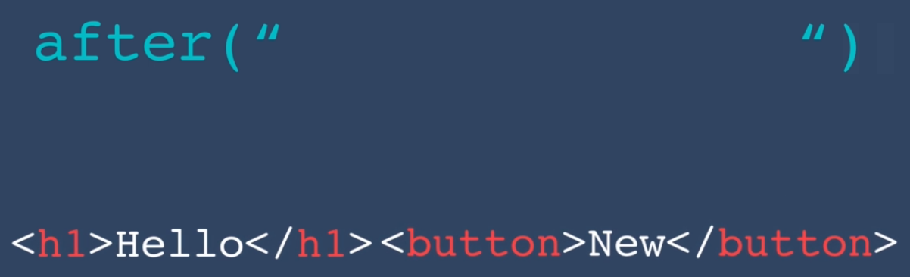

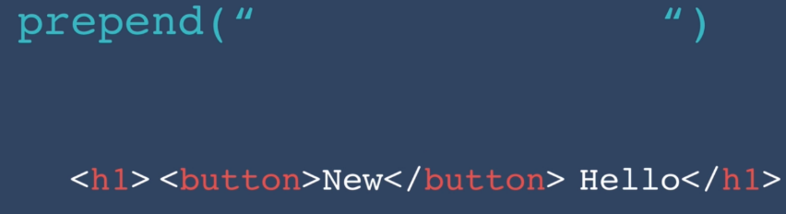

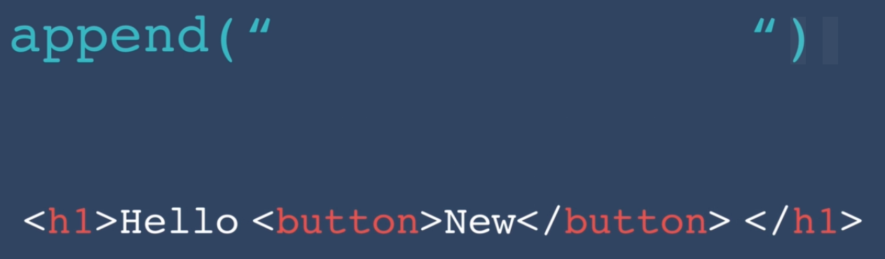

* Here “<button>New</button>” was passed as an argument in each of these functions while h1 was selected as $(“h1”).funciton and so on.
* If you want to remove an element you can do so by using the remove method. Just use the $ to select your HTML element and call the .remove() method, it will remove all your elements from it.

**Lecture 10 (Website Animations with jQuery)**

* You can use jQuery to add animations to elements.
* Simply select the element using the $ method and then you can use a number of animations such as hide, fadeIn, fadeout, fadeToggle, slideToggle etc.
* You can also combine animations like this

